444

Hyundai’s All-New 2019 Santa Fe Awarded
Redesign of the Year by ALG®

FOUNTAIN VALLEY, Calif., Jan. 14, 2019 – Hyundai’s all-new 2019 Santa Fe captured the Redesign of the Year award by ALG today. The prestigious award recognizes Santa Fe’s all-new family-oriented interior, loaded with practical cutting-edge technologies and bold exterior appearance. ALG, the analytics subsidiary of TrueCar®, Inc., is the benchmark for forecasting future vehicle values and their relevance to automotive leasing. ALG’s newly created Redesign of the Year awards were determined by measuring the degree of vehicle change and the quality of its execution.
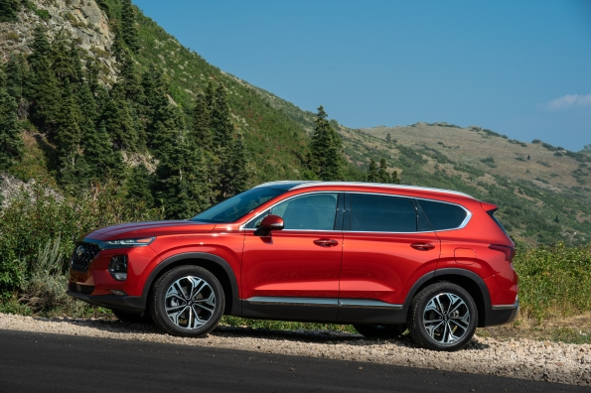
Redesign of the Year, 2019 Hyundai Santa Fe

“The Redesign of the Year award for Santa Fe clearly recognizes our efforts in delivering a bolder design language for Hyundai’s best-selling SUV in the United States,” said Scott Margason, director, Product Planning, Hyundai Motor America. “The comprehensive suite of safety features, comfort and convenience technologies, increased visibility, as well as, interior cabin and storage space, represent the attributes consumers are seeking in this highly competitive SUV segment.”

Hyundai has achieved success with the redesigned Santa Fe in one of the largest and most competitive segments in the industry, according to ALG. The exterior moves progressively from its predecessor, boasting a more aggressive front fascia with bold lines carrying to the rear of the vehicle. The interior receives a full freshening, creating a modern ambience with a larger center display, refined instrument cluster and an optional panoramic sunroof with a shade that adjusts to increase ambient light. Hyundai’s overall degree of change and execution certainly warrant Santa Fe’s achievement as the ALG Redesign of the Year.

The Hyundai Santa Fe offers exceptional value by offering a number of standard safety and convenience features. Hyundai’s SmartSense – an umbrella for active driver safety and convenience technologies – is standard on the Santa Fe. These technologies include: Forward Collision-avoidance Assist, Lane Keeping Assist, Driver Attention Warning, Rear Cross-traffic Collision Warning, Safe Exit Assist and Rear View Monitor with Parking Guidance. Parking Distance Warning and Rear Occupant Alert (a Hyundai first) are standard on the SEL Plus and above trims.

Premium touches such as the layered, three-dimensional instrument panel and contrasting seat stitching ensures a high level of luxury within the cabin. The new Santa Fe’s exterior has also grown in size, giving the vehicle even more presence. With a length of 188 inches, a width of 74 inches and a longer wheelbase, it also provides more comfort for passengers than the outgoing 2018 Santa Fe Sport. All Santa Fe’s come standard with tilt-and-telescopic steering wheel with audio, Bluetooth® and cruise controls, and a 7-inch Display Audio touchscreen system with both Apple CarPlay™ and Android Auto™ capability. To eliminate the need for a charging cord, there’s an available Qi wireless charging pad for compatible Android devices, as well as Apple iPhone 8 and iPhone X.

The 2019 Santa Fe line-up offers a choice of proven powertrains. There is a 2.4-liter inline four-cylinder GDI engine with 185 horsepower or a more powerful, turbocharged 2.0-liter four-cylinder engine with 235 horsepower. All engines are mated to a brand-new eight-speed automatic transmission.

ALG®
Founded in 1964 and headquartered in Santa Monica, California, ALG is an industry authority on automotive residual value projections in both the United States and Canada. By analyzing nearly 2,500 vehicle trims each year to assess residual value, ALG provides auto industry and financial services clients with market industry insights, residual value forecasts, consulting and vehicle portfolio management and risk services. ALG is a wholly-owned subsidiary of TrueCar, Inc., a digital automotive marketplace that provides comprehensive pricing transparency about what other people paid for their cars. ALG has been publishing residual values for all cars, trucks and SUVs in the U.S. for over 50 years and in Canada since 1981.

HYUNDAI MOTOR AMERICA
Hyundai Motor America is focused on delivering an outstanding customer experience grounded in design leadership, engineering excellence and exceptional value in every vehicle we sell. Hyundai’s technology-rich product lineup of cars, SUVs and alternative-powered electric and fuel cell vehicles is backed by Hyundai Assurance—our promise to deliver peace of mind to our customers. Hyundai vehicles are sold and serviced through more than 830 dealerships nationwide and the majority sold in the U.S. are built at U.S. manufacturing facilities, including Hyundai Motor Manufacturing Alabama. Hyundai Motor America is headquartered in Fountain Valley, California, and is a subsidiary of Hyundai Motor Company of Korea.
Please visit our media website at www.HyundaiNews.com
Hyundai Motor America on Twitter | YouTube | Facebook | Instagram

###

Contact:
Michele Tinson
734-740-4650
mtinson@hmausa.com

