Hyundai IONIQ 5 and Palisade Named 2022 CarBuzz
Award Winners

- Hyundai IONIQ 5 Wins “People’s Car” Category
- Hyundai Palisade Wins “Family Fun” Category

FOUNTAIN VALLEY, Calif., Dec. 6, 2022 – Today, the 2022 Hyundai IONIQ 5 earned the 2022 CarBuzz.com People’s Car Award and the 2023 Hyundai Palisade earned the 2022 CarBuzz Family Fun Award. CarBuzz Awards represent the best vehicles across 10 categories, each with its own unique criteria on which winners are selected.

The People’s Car Award is aimed at vehicles delivering an outstanding overall package at their price point. To qualify for the award, vehicles must be priced below the average new car MSRP for 2022 ($48,000). The Family Fun Award is aimed at vehicles that can accommodate families of all sizes while still being fun-to-drive.

The IONIQ 5 continues to break new ground in the crossover segment with best-in-class ultra-fast charging from 10 to 80 percent in just 18 minutes under optimum charging conditions, more than 300 miles of range for the RWD trim, a sleek design and a starting price of $41,450.

Palisade is Hyundai’s flagship SUV. It combines a roomy cabin for up to eight passengers along with a robust V6 engine. Palisade excels at making road trips and daily commutes enjoyable for the entire family, not just the driver.

“These honors from CarBuzz recognize not only the high level of execution of the IONIQ 5 and Palisade, but also their feature-packed driving experience,” said Olabisi Boyle, vice president, Product Planning and Mobility Strategy, Hyundai Motor North America.

Quotes From the Editor at CarBuzz
2023 Hyundai IONIQ 5
“The 2023 Hyundai IONIQ 5 proves that an electric vehicle can be the perfect People’s Car,” says Jared Rosenholtz, CarBuzz Editor-at-Large. “With a starting price of $41,450, over 300 miles of available driving range, and the quickest charging speeds of any mainstream EV, the IONIQ 5 is the car that will convince buyers to go electric.”

“Hyundai is the first automaker to win the People’s Car Award with an EV, proving that the future is bright for affordable electrification,” Rosenholtz adds. “Many EVs arriving on the market now can’t match the IONIQ 5’s charging speeds, showing just how far ahead the Hyundai Motor Group is in this segment.”

2023 Hyundai Palisade
“I can’t imagine buying another family SUV over the 2023 Hyundai Palisade,” claims Jared Rosenholtz, CarBuzz Editor-at-Large. “For less than $50,000 (even in the top trim), the Palisade bundles features you won’t find at double the price. It even offers ventilated second-row and heated third-row seats, an amenity you won’t find on most six-figure Germany luxury SUVs.”

“The Palisade was our first Family Fun winner in the inaugural CarBuzz Awards,” Rosenholtz explains. “Frankly, the Palisade could have won every year since then, but we only allow cars that are new or updated to compete. With the 2023 facelift, Hyundai improved upon its award-winning formula and again showed it can build the ultimate family SUV.”
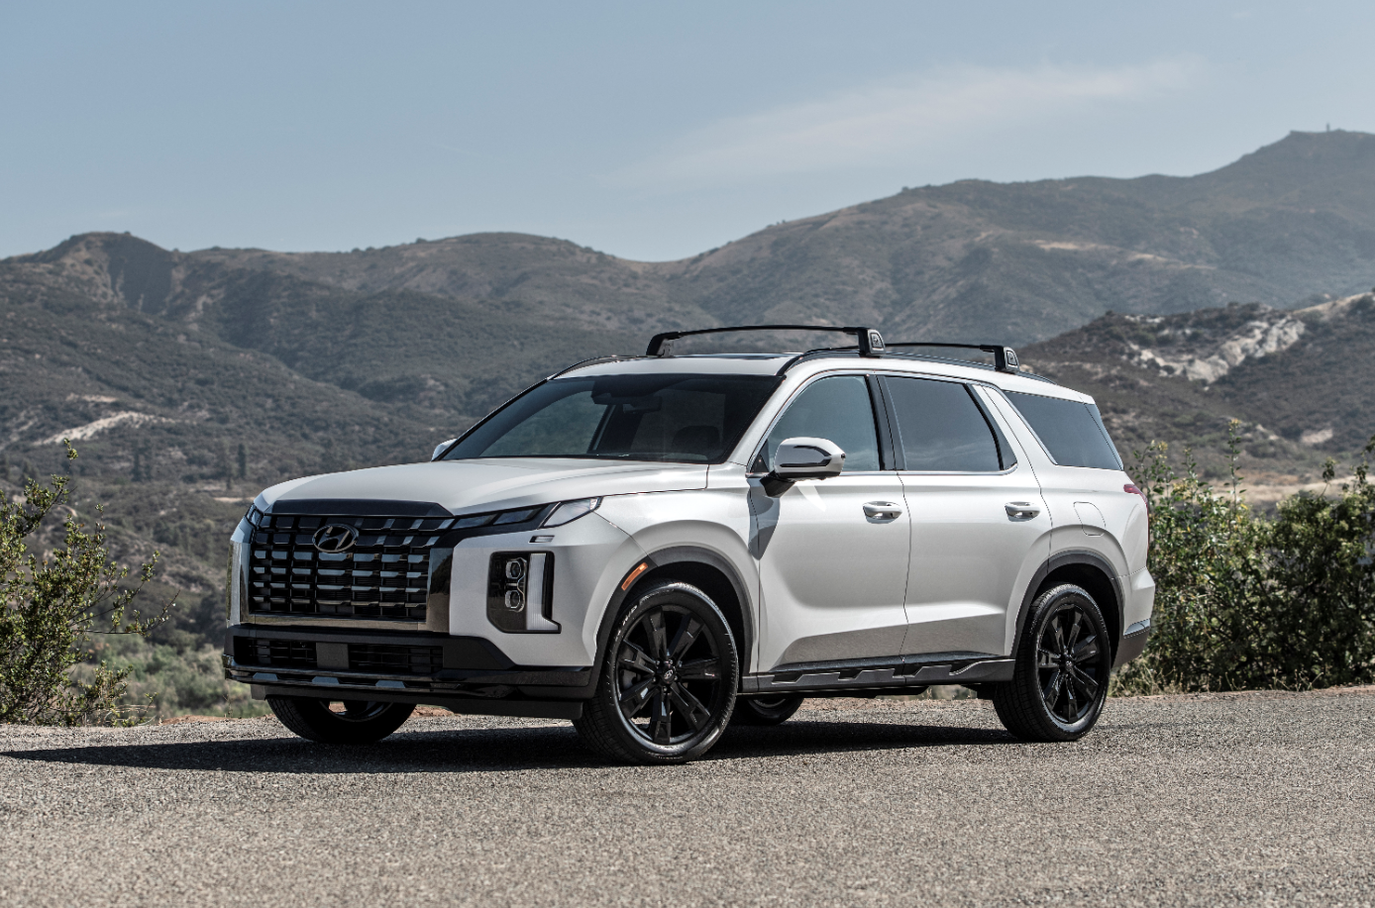
The 2023 Palisade XRT with optional features shown is photographed in Santiago, Calif., on May 26, 2022.

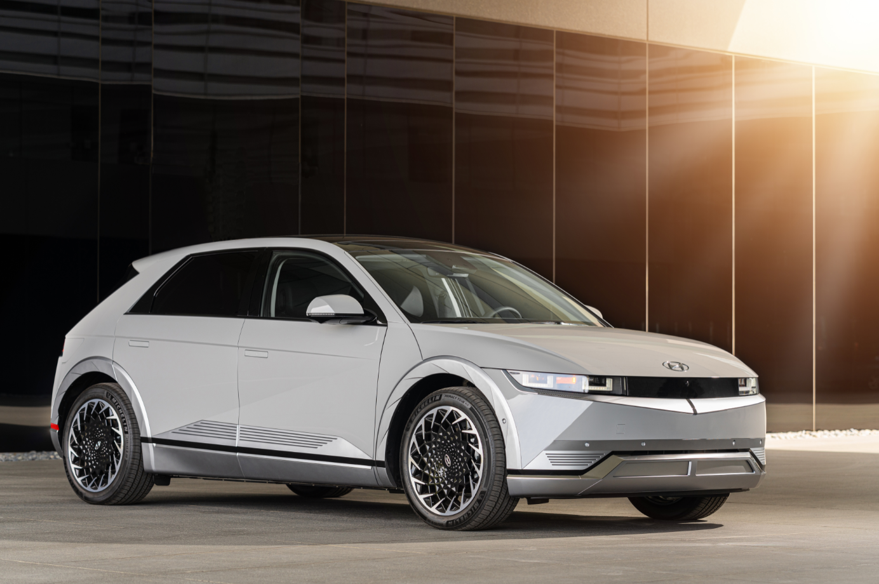
The 2022 IONIQ 5 with optional features shown is photographed in Fountain Valley, Calif., on Dec. 7, 2021.

Hyundai Motor America
Hyundai Motor America focuses on ‘Progress for Humanity’ and smart mobility solutions. Hyundai offers U.S. consumers a technology-rich lineup of cars, SUVs, and electrified vehicles. Our 820 dealers sold more than 738,000 vehicles in the U.S. in 2021, and nearly half were built at Hyundai Motor Manufacturing Alabama. For more information, visit www.HyundaiNews.com.

Hyundai Motor America on Twitter | YouTube | Facebook | Instagram | LinkedIn

###

Contact
Miles Johnson
(714) 366-1048
milesjohnson@hmausa.com

Approximately 18 minutes to charge from 10% to 80% on a 350-kW, 800V DC ultra-fast charger. Actual charging time varies based on a number of factors, including current battery charge level, output of the charging unit, vehicle and battery settings and outside temperature.
EPA-estimated 303 mile driving range for 2023 IONIQ 5 SE/SEL/Limited RWD; 266 mile driving range for IONIQ 5 SE/SEL/Limited AWD; and 220 mile driving range for IONIQ 5 SE RWD (Standard Range). All figures are EPA estimates and based on a fully charged battery. For comparison purposes only. Battery capacity decreases with time and use. Actual range will vary based on a number of factors, including vehicle options, driving conditions and habits, vehicle and battery's condition and outside temperature.

