Hyundai IONIQ 5 and Santa Fe Win Prestigious
2023 Kelley Blue Book Best Buy Awards

- 2023 IONIQ 5 Wins 2023 Best Buy Awards for New Model and Electric Vehicle Segments
- 2023 Santa Fe Wins 2023 Best Buy Award for Two-Row Midsize SUV Segment
- Best Buy Awards Helps New Car Buyers Find the Very Best Vehicles by Segment
- NASCAR Driver Toni Breidinger Teams Up with Kelley Blue Book to Test 2023 Best New Model Winner Hyundai IONIQ 5

FOUNTAIN VALLEY, Calif., Dec. 15, 2022 – Hyundai received three awards in this year’s Kelley Blue Book Best Buy Awards. The IONIQ 5 took home two categories, winning the Electric Vehicle segment and the New Model segment, this year’s highest honor. The Santa Fe won in the Two-Row Midsize SUV segment. The Best Buy Awards are the culmination of expert vehicle evaluation and testing of nearly every new vehicle available. The comprehensive process includes an analysis of vehicle-related data, including vehicle transaction prices, 5-Year Cost-to-Own data, consumer reviews, ratings, and retail sales information.

This year, Kelley Blue Book partnered with NASCAR driver Toni Breidinger. Breidinger joined Kelley Blue Book’s editors for a day of driving the Hyundai IONIQ 5, sharing her thoughts and driving impressions as she evaluated the all-new model through the lens of a racecar driver.

“The goal for the IONIQ 5 was to exceed our customers’ expectations when compared with a similar ICE powered SUV,” said Ricky Lao, director, product planning, Hyundai Motor North America. “We wanted to give them something special and IONIQ 5’s design, ultra-fast charging, spacious interior and driving range of more than 300 miles (with select RWD trims) does just that. And Santa Fe is an outstanding family SUV with great looks.”
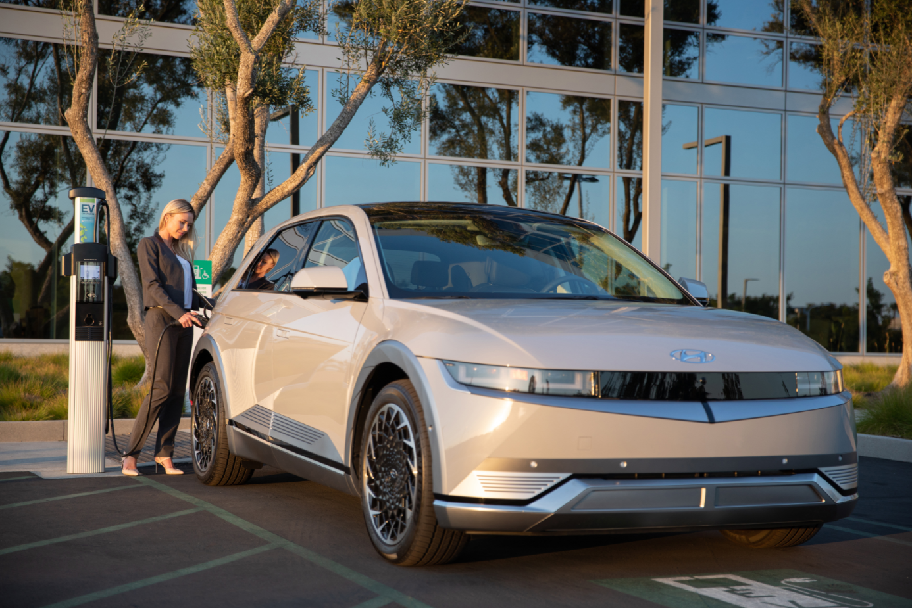
The Hyundai IONIQ 5 is photographed in Irvine, Calif., on July 20, 2022
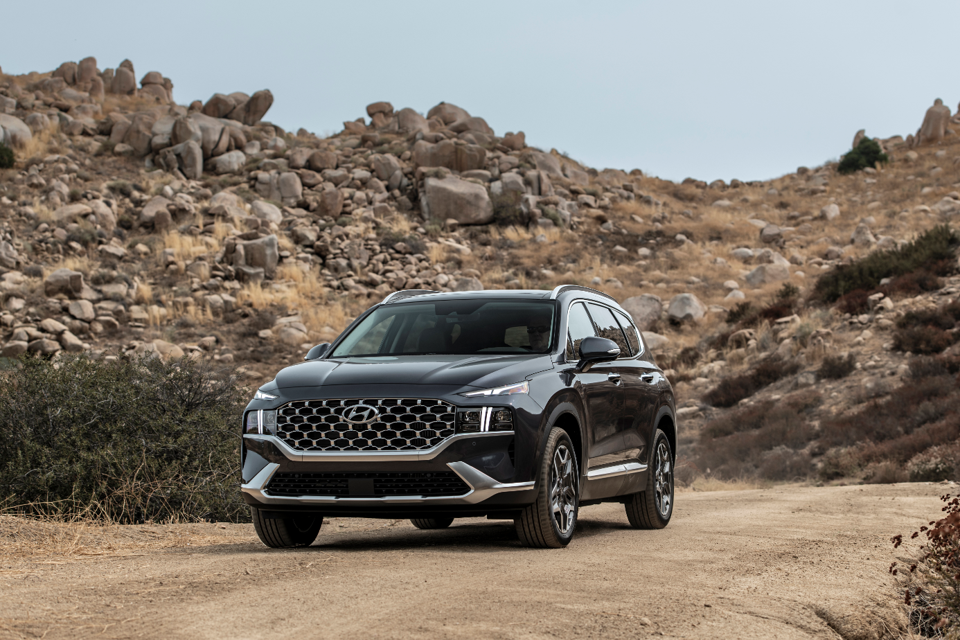
The Hyundai Santa Fe is photographed in Silverado Canyon, Calif. on Aug. 9, 2022
Quotes from Kelley Blue Book and Toni Breidinger
“The number of electric vehicles available to new-car shoppers continues to increase at a staggering pace, and the competition continues to get hotter as these efficient rides gain popularity among consumers,” said Jason Allan, principal editor of reviews and ratings for Kelley Blue Book. “Our team was so impressed with the all-new Hyundai IONIQ 5 during this year’s Best Buy Awards testing that we didn’t just give it the title of Best Electric Vehicle for 2023, it also earned our Best New Model trophy. It is truly a vehicle that exemplifies how easy it can be now to go all-electric, boasting the kind of impressive range and tech features that consumers have come to expect, and offering terrific value relative to the competition.”

“As a lifelong automotive enthusiast, it was a thrill to join the experts from Kelley Blue Book for a day to put the 2023 Hyundai IONIQ 5 to the test,” said Toni Breidinger, NASCAR driver. “The spacious interior and extended dashboard really stood out to me. Most importantly, I appreciated the all-electric range. After a test day with the IONIQ 5, I can confirm this year’s Best New Model is racer-approved.”

Praise for the IONIQ 5 from Kelley Blue Book
With more than 300 miles of range with select RWD trims, a spacious, tech-filled interior and an impressive starting price, the Hyundai IONIQ 5 shows how easy it can be for someone to go all electric. You can even go from 10 percent charge to 80 percent in as little as 18 minutes under optimum charging conditions. The Hyundai IONIQ 5’s retro-inspired styling turns heads, but the 303-mile range^{i} combined with its impressive, easy-to-use tech and spacious interior at a good price solidify this vehicle a Best Buy.

Praise for the Santa Fe from Kelley Blue Book
We recognize not only the immense value of this 5-passenger SUV but also its wide appeal. Hyundai hangs its collective hat on its value story, and nowhere is that value more apparent than in the level and quality of its technology. To find an SUV at this price point with this degree of attention to detail inside and out is a tribute to Hyundai’s genius for making every dollar count.

For more information and news from Kelley Blue Book's KBB.com, visit www.kbb.com/media/, follow us on LinkedIn at https://www.linkedin.com/company/kelley-blue-book/, Twitter at www.twitter.com/kelleybluebook (or @kelleybluebook), like our page on Facebook at www.facebook.com/kbb and follow us on Instagram at https://www.instagram.com/kbb_com/ (or @kbb_com).

About Kelley Blue Book
Founded in 1926, Kelley Blue Book, The Trusted Resource®, is the vehicle valuation and information source trusted and relied upon by both consumers and the automotive industry for nearly a century. As the industry standard for generations, Kelley Blue Book provides transparent, objective information and data-driven, innovative tools for consumers, automotive dealers and manufacturers. The company publishes millions of market-reflective values weekly on its top-rated website KBB.com, from its famous Blue Book® Trade-In Values to the Kelley Blue Book® Price Advisor tool, which offers a range for what consumers reasonably can expect to pay for a vehicle in their area. KBB.com editors rate and review hundreds of new vehicles each year to help consumers understand the Best Cars and Best SUVs to meet their needs. Kelley Blue BookSM Instant Cash Offer provides a redeemable trade-in offer to transaction-ready consumers and conveniently connects them to local participating dealers. Kelley Blue Book’s Service Advisor provides guidance on how much to pay for service and repairs, allowing consumers to schedule service with local dealers on KBB.com. The company also provides vehicle values to finance and insurance companies as well as governmental agencies. Kelley Blue Book is a Cox Automotive brand.

Hyundai Motor America
Hyundai Motor America focuses on ‘Progress for Humanity’ and smart mobility solutions. Hyundai offers U.S. consumers a technology-rich lineup of cars, SUVs, and electrified vehicles. Our 820 dealers sold more than 738,000 vehicles in the U.S. in 2021, and nearly half were built at Hyundai Motor Manufacturing Alabama. For more information, visit www.HyundaiNews.com.

Hyundai Motor America on Twitter | YouTube | Facebook | Instagram | LinkedIn

###

Contact
Miles Johnson
(714) 366-1048
milesjohnson@hmausa.com

EPA-estimated 303-mile driving range for 2023 IONIQ 5 SE/SEL/Limited RWD; 266-mile driving range for IONIQ 5 SE/SEL/Limited AWD; and 220 mile driving range for IONIQ 5 SE RWD (Standard Range). All figures are EPA estimates and based on a fully charged battery. For comparison purposes only. Battery capacity decreases with time and use. Actual range will vary based on a number of factors, including vehicle options, driving conditions and habits, vehicle and battery's condition and outside temperature.
Approximately 18 minutes to charge from 10% to 80% on a 350-kW, 800V DC ultra-fast charger. Actual charging time varies based on a number of factors, including current battery charge level, output of the charging unit, vehicle and battery settings and outside temperature.

